**1. How to display different images to two eyes?**

In order to see things in 3D each eye must see a slightly different picture. This is done in the real world by your eyes being spaced apart so each eye has its own slightly different view. The brain then puts the two pictures together to form one 3D image that has depth to it.

Methods:

**(1) Color Filter Glasses**

The same scene is projected simultaneously from two different angles in two different colors, red and cyan (or blue or green). The color filter glasses separates the two different images so each image only enters one eye and your brain puts the two images back together. You cannot really have a color movie when you are using color to provide the separation, so the image quality is not nearly as good as with the polarized system.

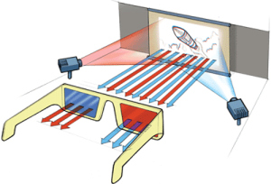

**(2) Polarized Glasses**

Two synchronized projectors project two respective views onto the screen, each with a different polarization. The glasses allow only one of the images into each eye because they contain lenses with different polarization.

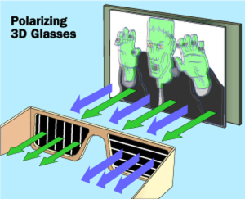

**(3) Synchronization between the screen and glasses (Active shutter 3D system)**

Rather than interleaving two half-resolution images in space, it interleaves two full resolution images in time. The TV rapidly alternates showing images for the left and right eye, while the glasses use electronic shutters synchronized to the TV to ensure that each eye sees a different image. This system is more complex but allows for a higher resolution 3D image.

Active shutter 3D systems generally use liquid crystal shutter glasses (also called "LCS glasses", "LCS 3D glasses", "LC shutter glasses" or "active shutter glasses"). Each eye's glass contains a liquid crystal layer which has the property of becoming opaque when voltage is applied, being otherwise transparent. The glasses are controlled by a timing signal that allows the glasses to alternately block one eye, and then the other, in synchronization with the refresh rate of the screen. The timing synchronization to the video equipment may be achieved via a wired signal, or wirelessly by either an infrared or radio frequency (e.g. Bluetooth, DLP link) transmitter.

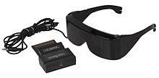

**2. Displaying disparity**

- Consider recovering the position of P from its projections pl and pr

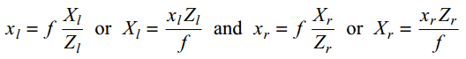

where f is the focal length of a camera.

- In general, the two cameras are related by the following transformation: Pr = Pl − T

where T is distance between the two cameras.

- Using Zr = Zl = Z and Xr = Xl − T, we have:



where d = xl - xr is the disparity (i.e., the difference in the position between the corresponding points in the two images)

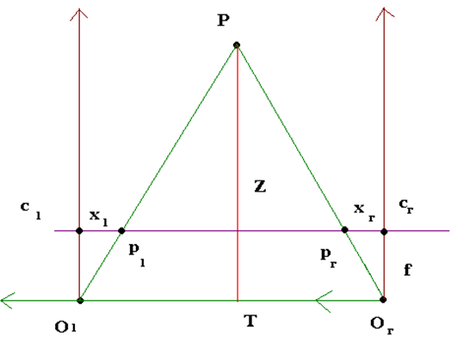

**3. Panoramic Image Stitcher - Warping(How to warp image to cylinder)**

**4. Panoramic Image Stitcher - Blending**

**5. Eliminating False Matches through Relaxation**

**6. Chamfer Distance + Distance transform**

**7. a. Color Constancy by Gray World**

**b. Color Constancy by Gamut Mapping**

**8. Energy minimization**

**9. C- rule algorithm + Retinex algorithm**